TASK 1 CODE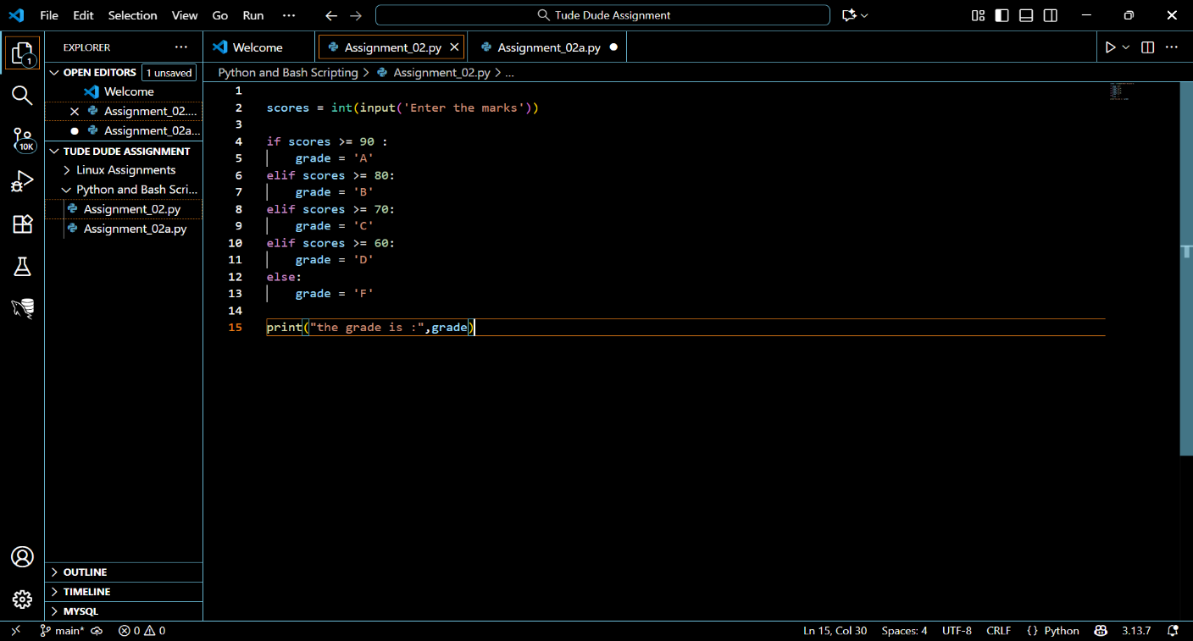

TASK 1 OUTPUT
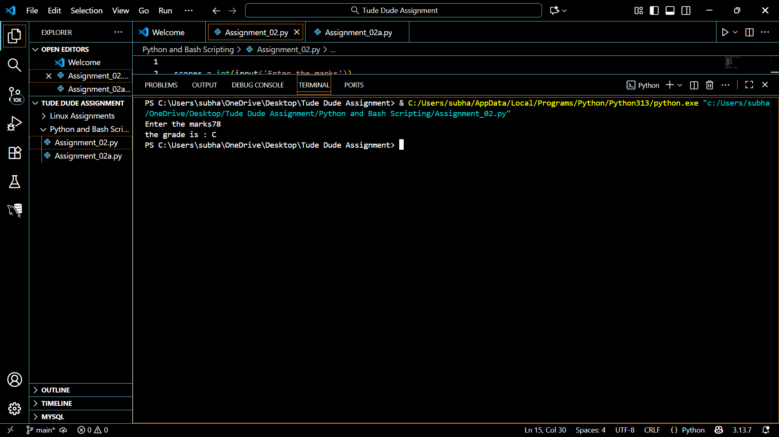
TASK 2 CODE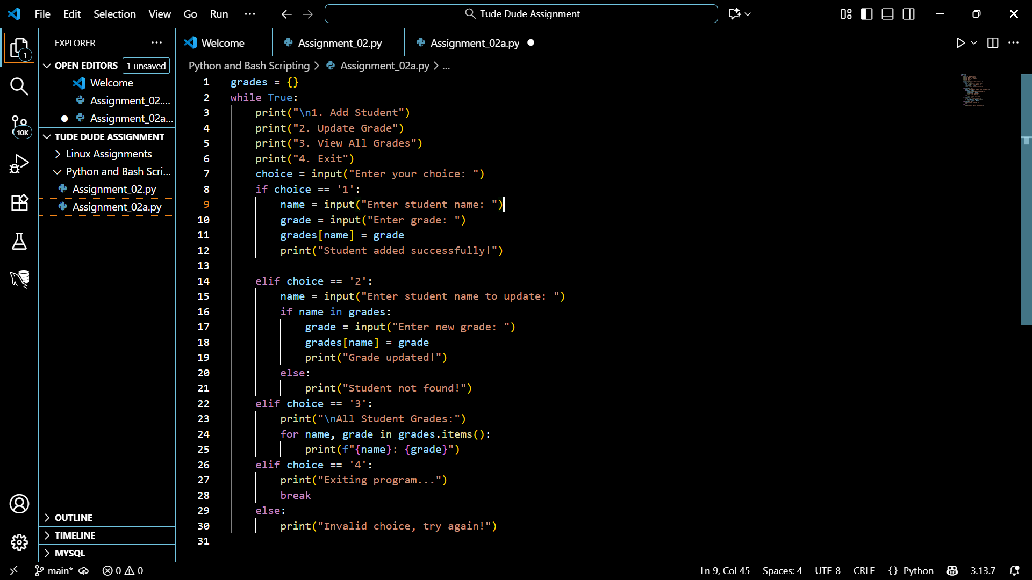

TASK 2 OUTPUT
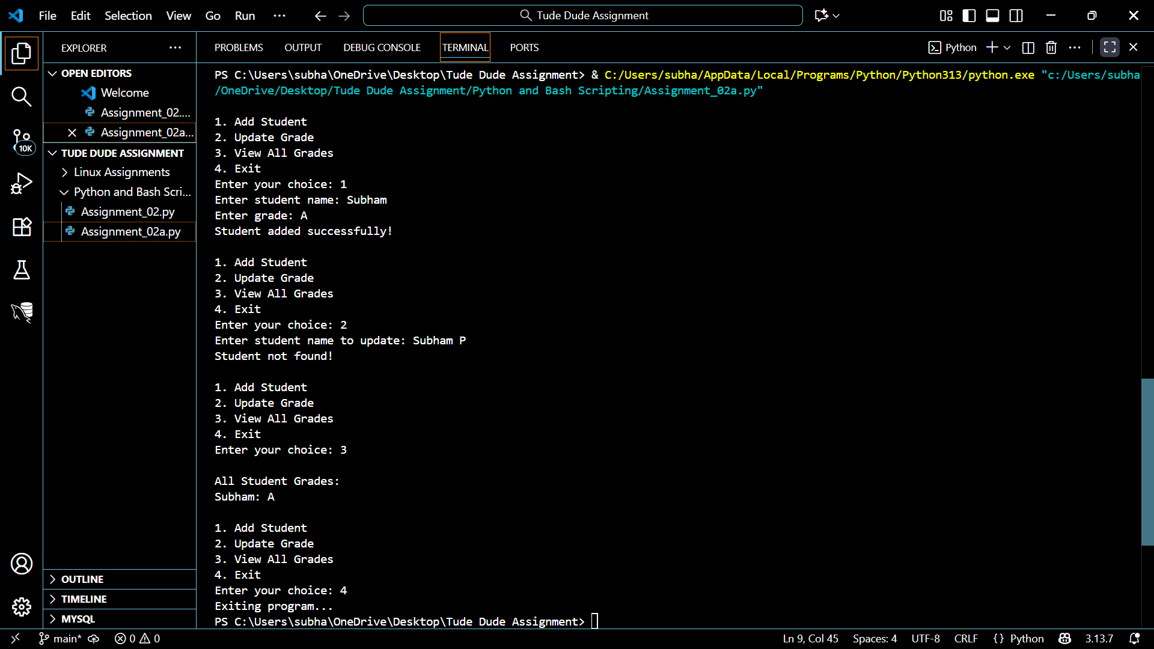

TASK 3 CODE AND OUTPUT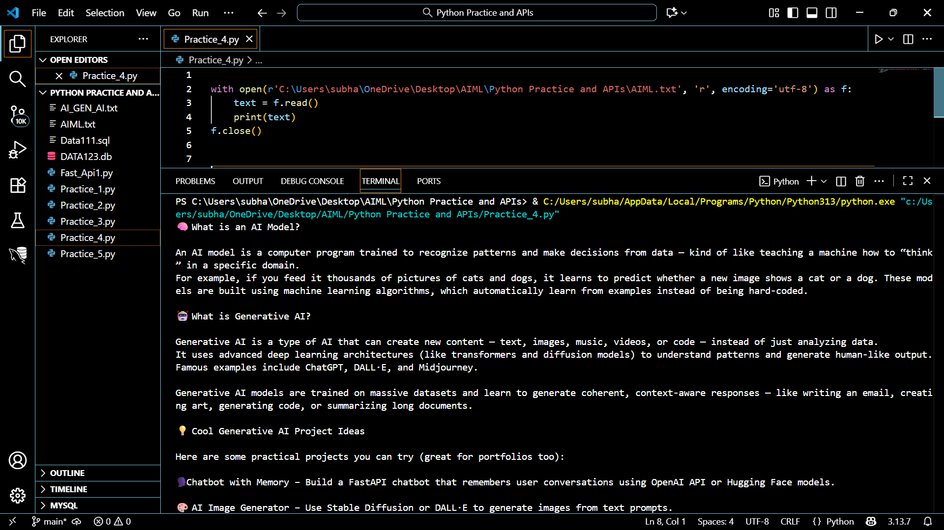

TASK 4 CODE AND OUTPUT
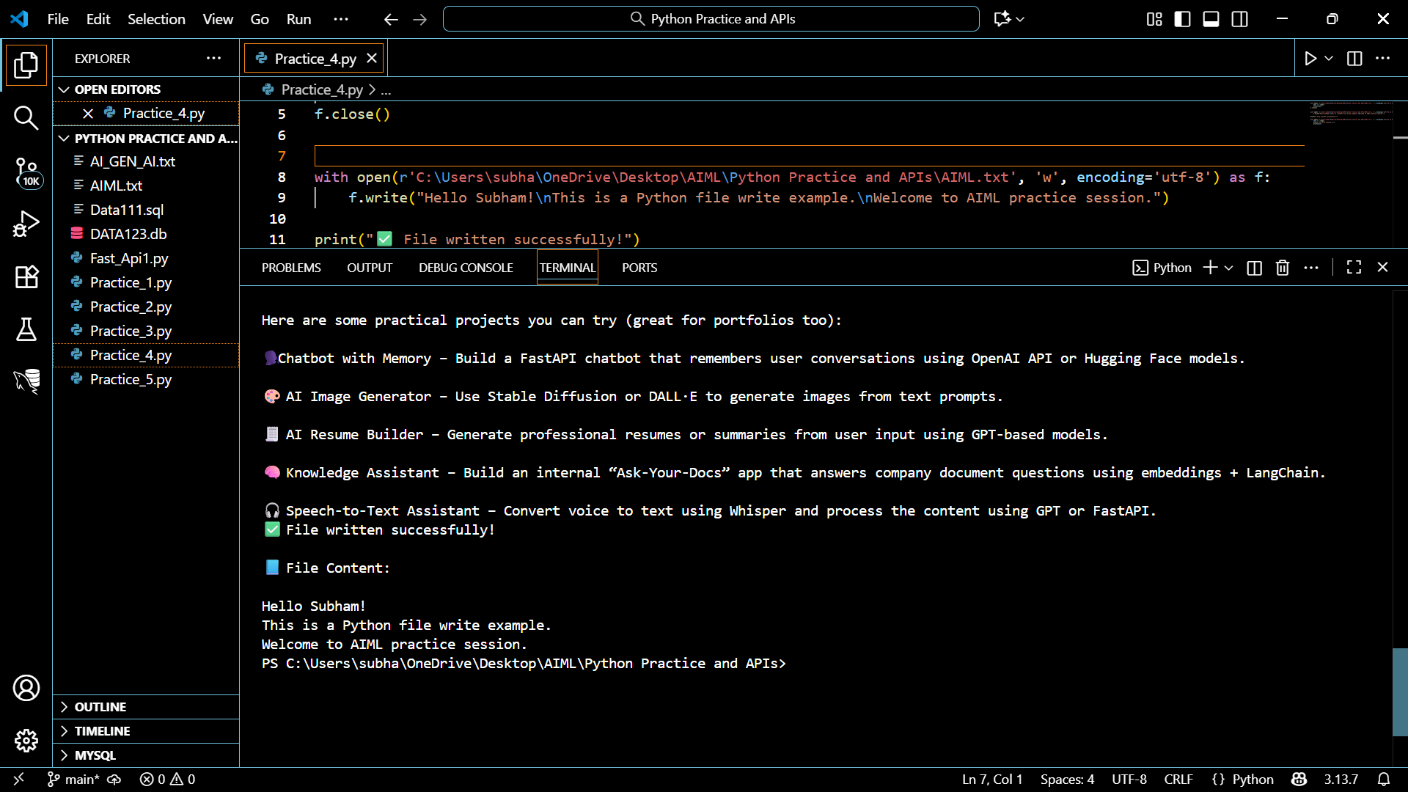

GITHUB LINK FOR THE SOLUTIONS

